**Web Service Testing Guide**

**Soap UI Tool**

**Introduction**

This document will help in testing CAS Web Services using Soap UI Tool

1. **Download Free Soap UI Tool**

<http://sourceforge.net/projects/soapui/files/>

1. **Creating a Project Soap UI Tool**

* Open the SOAP UI Tool.
* Create a New SOAP Project from File Menu
* Give a name to the Project like “CAS Services” and Click Ok.

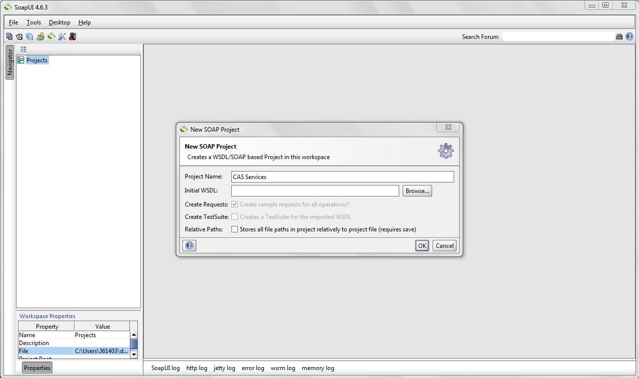

1. **Importing WSDL into the SOAP Project**

* Right Click on the Project listed on the Tree in the left pane and select “Add WSDL”

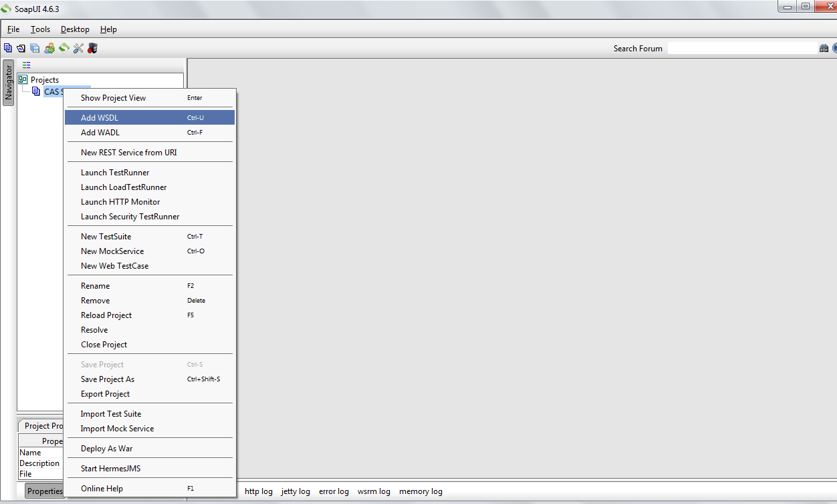

* Right Click on the Project listed on the Tree in the left pane and select “Add WSDL”. Paste the URL in the field of WSDL location and Click OK.

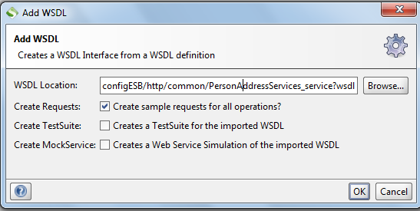

* Double Click on the Leaf Node named Request1. In the New Window Pop up, Click on the “Auth” Tab at the Bottom Left of the Window.

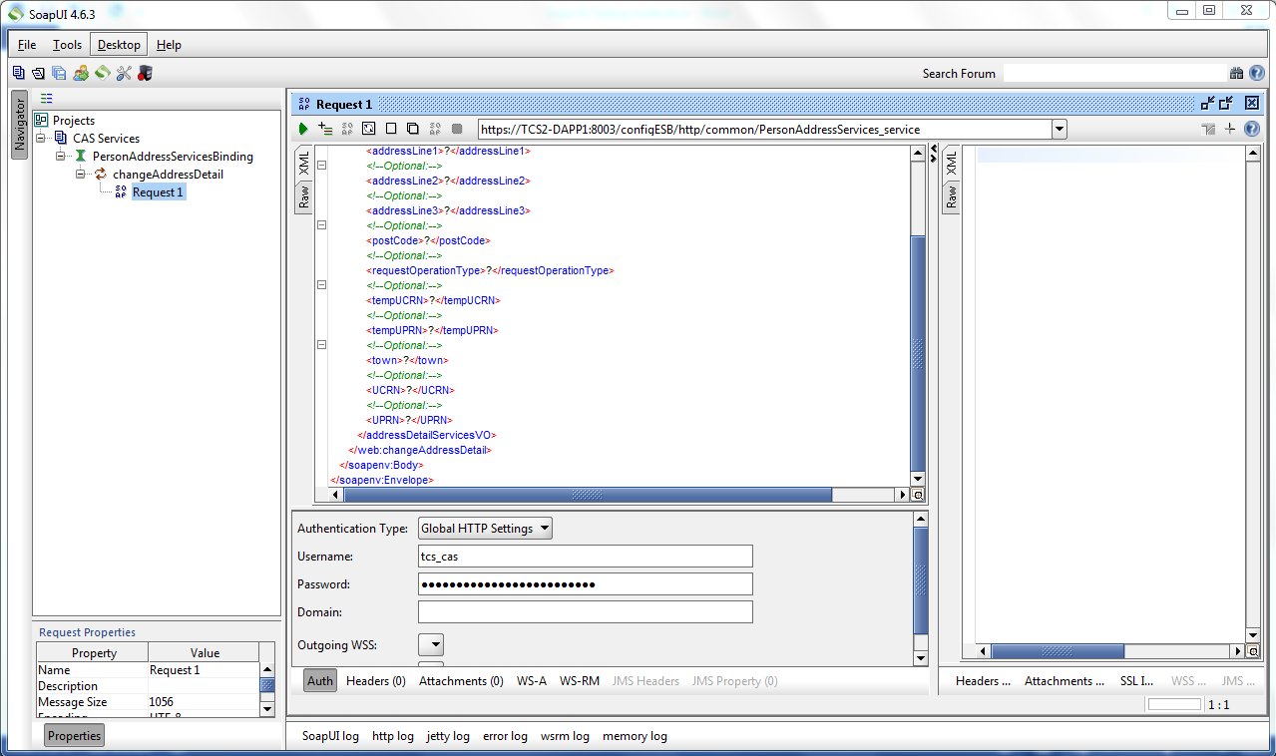

* Enter Username and Password in the Provided Fields. Note that the Password has to be Encrypted Text if the Web Service Authentication Handler is configured to accept Encrypted Password.
* In the left pane expand the Request Properties Section.

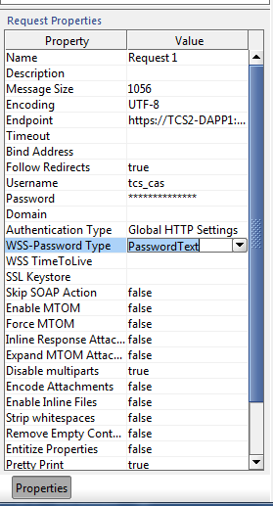

* Select the WSS-Password Type as “PasswordText”.

1. **Calling the Web Service**

* Confirm the Endpoint URL in the Request Window and change the HOSTNAME:PORT if required.

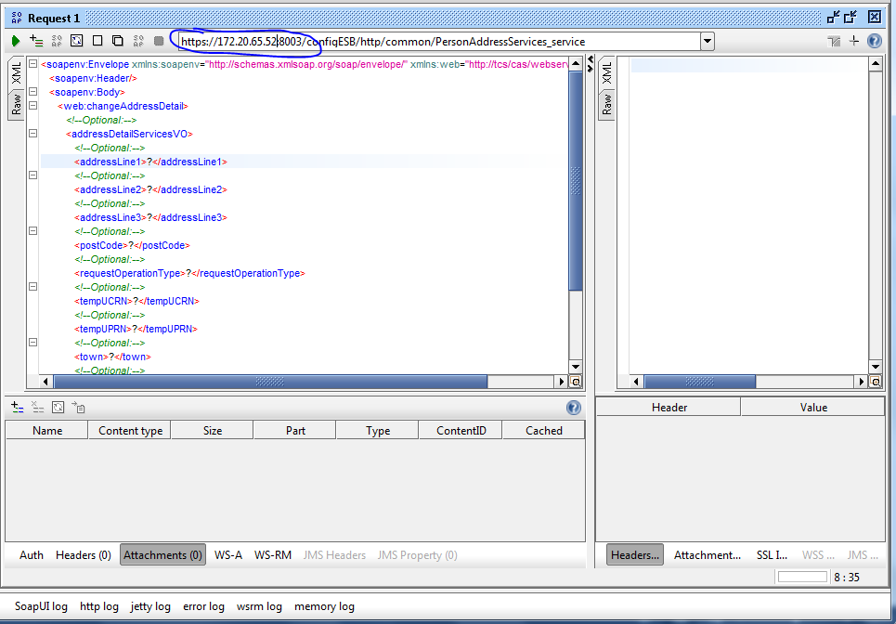

* Replace all the place holders (?) in the Request Part with the Values required and Click on the Green Button on the top to call the Web Service.

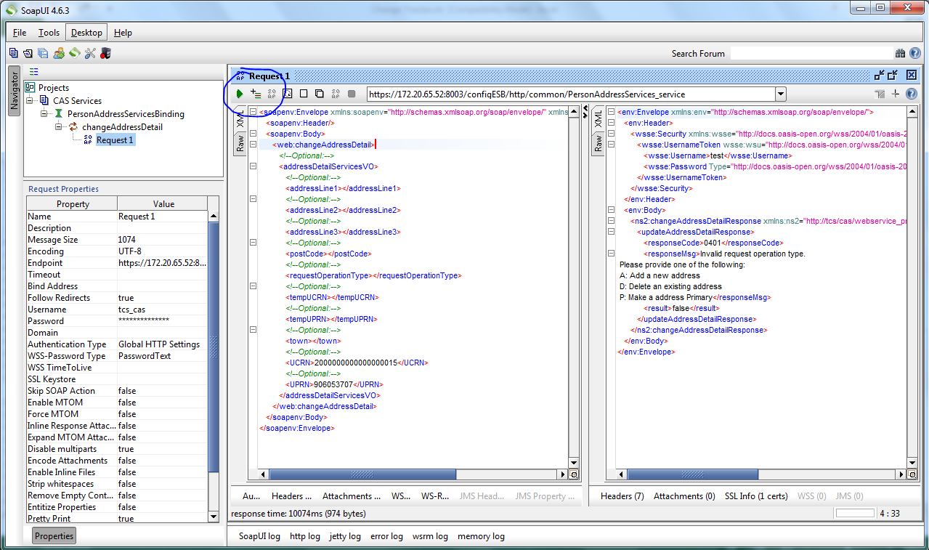

* The Web Service Call Response can be seen on the Right Pane.

1. **Make sure you save your SOAP Project.**